**LEARN PYTHON: FILES**

**Reading a File**

Computers use file systems to store and retrieve data. Each [file](https://www.codecademy.com/resources/docs/python/files?page_ref=catalog) is an individual container of related information. If you’ve ever saved a document, downloaded a song, or even sent an email you’ve created a file on some computer somewhere. Even **script.py**, the Python program you’re editing in the learning environment, is a file.

So, how do we interact with files using Python? We’re going to learn how to read and write different kinds of files using code. Let’s say we had a file called **real_cool_document.txt** with these contents:

**real_cool_document.txt**

Wowsers!

We could read that file like this:

**script.py**

with open('real_cool_document.txt') as cool_doc:  
  cool_contents = cool_doc.read()  
print(cool_contents)

This opens a file object called cool_doc and creates a new indented block where you can read the contents of the opened file. We then read the contents of the file cool_doc using cool_doc.read() and save the resulting string into the variable cool_contents. Then we print cool_contents, which outputs the statement Wowsers!.

**Instructions**

**1.**

Use with to open the file **welcome.txt**. Save the file object as text_file.

Checkpoint 2 Passed

Hint

Use this syntax to open a file:

with open('filename.txt') as file_object:  
  # indented block here

**2.**

Read the contents of text_file and save the results in text_data.

Checkpoint 3 Passed

Hint

Use this syntax on a file object to read the contents of the file into a variable:

file_string = file_object.read()

**3.**

Print out text_data.

**script.py**

with open('welcome.txt') as text_file:

  text_data = text_file.read()

print(text_data)

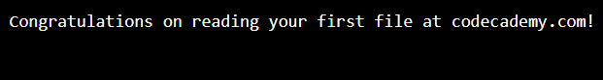

**Iterating Through Lines**

When we read a file, we might want to grab the whole document in a single string, like .read() would return. But what if we wanted to store each line in a variable? We can use the .readlines() function to read a text file line by line instead of having the whole thing. Suppose we have a file:

**keats_sonnet.txt**

To one who has been long in city pent,  
’Tis very sweet to look into the fair  
And open face of heaven,—to breathe a prayer  
Full in the smile of the blue firmament.

**script.py**

with open('keats_sonnet.txt') as keats_sonnet:  
  for line in keats_sonnet.readlines():  
    print(line)

The above script creates a temporary file object called keats_sonnet that points to the file **keats_sonnet.txt**. It then iterates over each line in the document and prints the entire file out.

**Instructions**

**1.**

Using a with statement, create a file object pointing to the file **how_many_lines.txt**. Store that file object in the variable lines_doc.

Checkpoint 2 Passed

Hint

Remember to open a file using with syntax:

with open('filename.txt') as file_object:  
  # indented block here

**2.**

Iterate through each of the lines in lines_doc.readlines() using a for loop.

Inside the for loop print out each line of **how_many_lines.txt**.

Checkpoint 3 Passed

Hint

You can use the following syntax to print out each line of a file:

for line in file_object.readlines():  
  print(line)

**script.py**

with open('how_many_lines.txt') as lines_doc:

  for line in lines_doc.readlines():

    print(line)

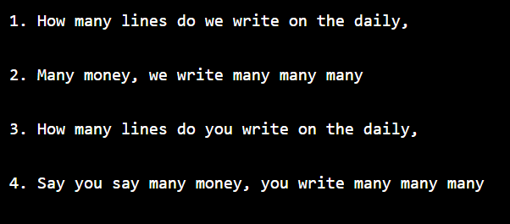

**Reading a Line**

Sometimes you don’t want to iterate through a whole file. For that, there’s a different file method, [.readline()](https://www.codecademy.com/resources/docs/python/files/readline?page_ref=catalog), which will only read a single line at a time. If the entire document is read line by line in this way subsequent calls to .readline() will not throw an error but will start returning an empty string (""). Suppose we had this file:

**millay_sonnet.txt**

I shall forget you presently, my dear,  
So make the most of this, your little day,  
Your little month, your little half a year,  
Ere I forget, or die, or move away,

**script.py**

with open('millay_sonnet.txt') as sonnet_doc:  
  first_line = sonnet_doc.readline()  
  second_line = sonnet_doc.readline()  
  print(second_line)

This script also creates a file object called sonnet_doc that points to the file **millay_sonnet.txt**. It then reads in the first line using sonnet_doc.readline() and saves that to the variable first_line. It then saves the second line (So make the most of this, your little day,) into the variable second_line and then prints it out.

**Instructions**

**1.**

Using a with statement, create a file object pointing to the file **just_the_first.txt**. Store that file object in the variable first_line_doc.

Checkpoint 2 Passed

Hint

Remember to open a file using with syntax:

with open('filename.txt') as file_object:  
  # indented block here

**2.**

Save the first line of **just_the_first.txt** into the variable first_line.

Checkpoint 3 Passed

Hint

Use the file object method .readline() to store a line into the variable line.

**3.**

Print out the variable first_line.

**script.py**

with open('just_the_first.txt') as first_line_doc:

  first_line = first_line_doc.readline()

  print(first_line)

